Template for Evidence(s)
UI GreenMetric Questionnaire

University : ...
Country : ...
Web Address : …

[1] Setting and Infrastructure (SI)
SAMPLE
[1.10] Total area on campus covered in planted vegetation (meter²)

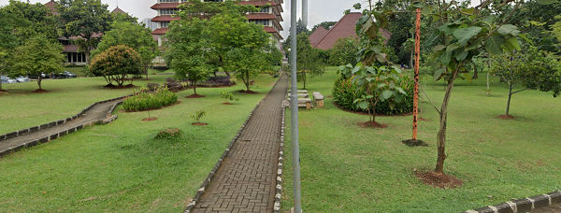 |  | 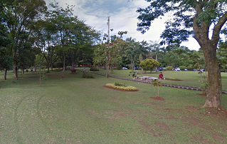
Taman 1 | Taman 2
Example of Total Planted Vegetation Area (Universitas Indonesia, Indonesia)

Description:
(Please describe the planted vegetation area in your campus. The following is an example of the description. You can describe more related items if needed.)

Total planted vegetation area: 193,530 m²
Total Area: 454.678 m2
Percentage area: 43%

Additional evidence link (i.e., for videos, more images, or other files that are not included in this file):

