Template for Evidence(s)
UI GreenMetric Questionnaire

University : ...
Country : ...
Web Address : …

[1] Setting and Infrastructure (SI)
SAMPLE
[1.3] Number of Campus Sites

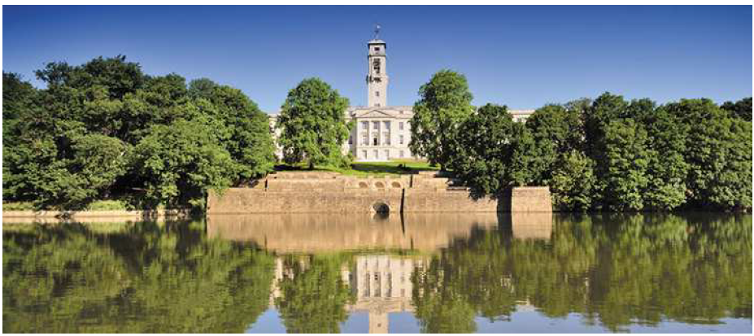 | Example of Campus Site, University  Park (University  of  Nottingham, UK)
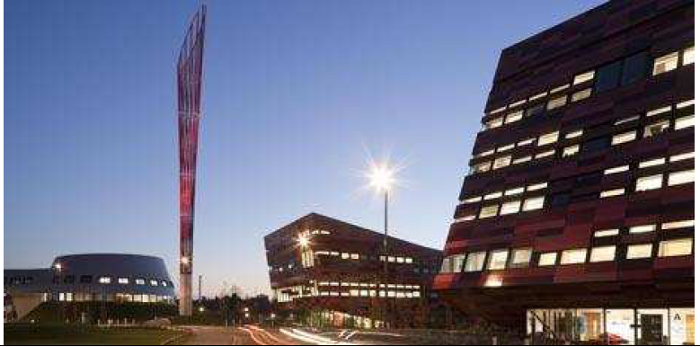 | Example of Campus Site, Jubilee  Campus (University  of  Nottingham, UK)

Description:
(Please describe your campus sites: area, date of establishment, history, facilities, etc. The following is an example of the description. You can describe more related items if needed)

University Park is The University of Nottingham’s largest campus at 300 acres. Part of the University since 1929, the campus is widely regarded as one of the largest and most attractive in the country. Set in extensive greenery and around a lake, University Park is the focus of life for students, staff and visitors. Conveniently located only two miles from the city center.
The Jubilee Campus is a modern purpose-built campus which now extends to 65 acres and is located only one mile from University Park. The initial phase was opened by Her Majesty the Queen in 1999.

Additional evidence link (i.e., for videos, more images, or other files that are not included in this file):

