Template for Evidence(s)
UI GreenMetric Questionnaire

University : ...
Country : ...
Web Address : …

[1] Setting and Infrastructure (SI)
SAMPLE
[1.9] Total Area on Campus Covered in Forest Vegetation (meter²)

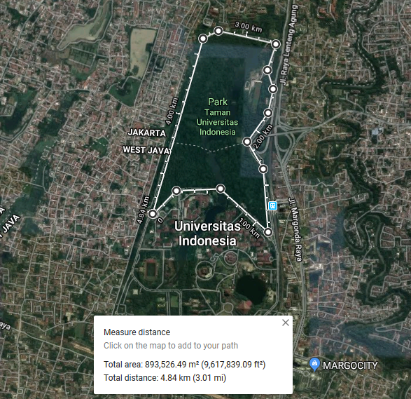
Example of Total Forest Vegetation Area (Universitas Indonesia, Indonesia)

Description:
(Please describe the forest vegetation area in your campus. The following is an example of the description. You can describe more related items if needed.)

Total area: 893,529,49 m²
Total distance/circumference: 4.84 km

Additional evidence link (i.e., for videos, more images, or other files that are not included in this file):

