Template for Evidence(s)
UI GreenMetric Questionnaire

University : ...
Country : ...
Web Address : …

[2] Energy and Climate Change (EC)
SAMPLE
[2.14] Impactful university program(s) on climate change

No | Programs | Scope (international / regional / national / local / etc) | Total Participants | Photo | URL | Short Description
1 | UI GreenMetric Online Course on Sustainability 2021  (September 2021 – January 2022) | International | 30 Teachers  89 Students | 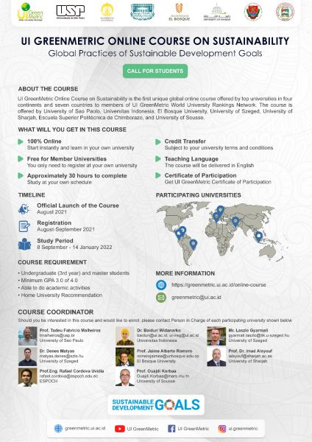 | https://greenmetric.ui.ac.id/online-course
2 | Program to build windmills as a power plant in the village of Bungin | Surrounding communities | ... | 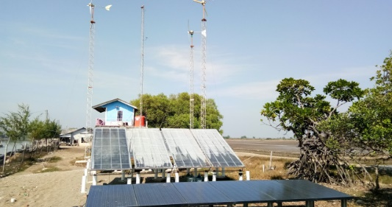 | http://pantaibakti.desa.id/2019/04/28/kampung-bungin-objek-wisata-bahari-berbasis-taman-teknologi/ | Faculty of Engineering of Universitas Indonesia build windmills as a power plant in the village of Bungin. With these windmills the village is able to produce electricity around 1000 watts/hour.

Additional infomrmation

