Template for Evidence(s)
UI GreenMetric Questionnaire

University : ...
Country : ...
Web Address : …

[3] Waste (WS)
SAMPLE
[3.5] Toxic Waste Treatment

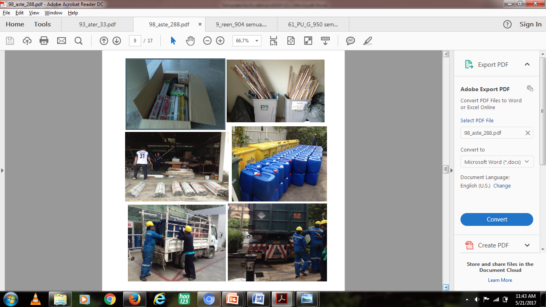 | 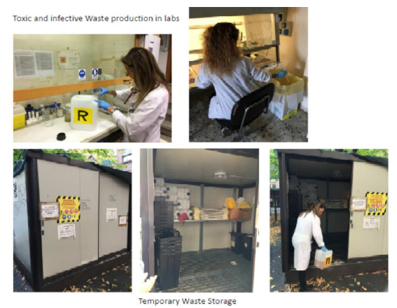
Example of Toxic Waste Treatment (Mahidol University, Thailand) | Example of Toxic Waste Treatment (Università di Bologna, Italy)

Description:
(Please describe the program to treat toxic waste on your campus. The following is an example of the description. You can describe more related items if needed.)

Management of (solid/liquid/gaseous) hazardous waste is directed by Nu.Te.R. (Waste Technical Team) in 41 Local Units spread out in all the University districts and cities. Every local unit is provided with:
- a Temporary Waste Storage (figure 1) to safely store the Hazardous Waste received from the labs where they are originated until they are picked up from the authorized Company;
- 1-3 trained Technicians, who give instruction for waste packaging and labeling and fill documents to comply with national and international regulations.
Specific typology of hazardous waste like WEEE is sent to recycling plants. Furthermore, a center for disused WEEE repair is starting at the Engineering Department of Civil, Chemical, Environmental & Materials Engineering (ref. Prof. Alessandra Bonoli).

Additional evidence link (i.e., for videos, more images, or other files that are not included in this file):

