Template for Evidence(s)
UI GreenMetric Questionnaire

University : ...
Country : ...
Web Address : …
SAMPLE
[3] Waste (WS)

[3.1] 3R (Reduce, Reuse and Recycle) Program for University Waste
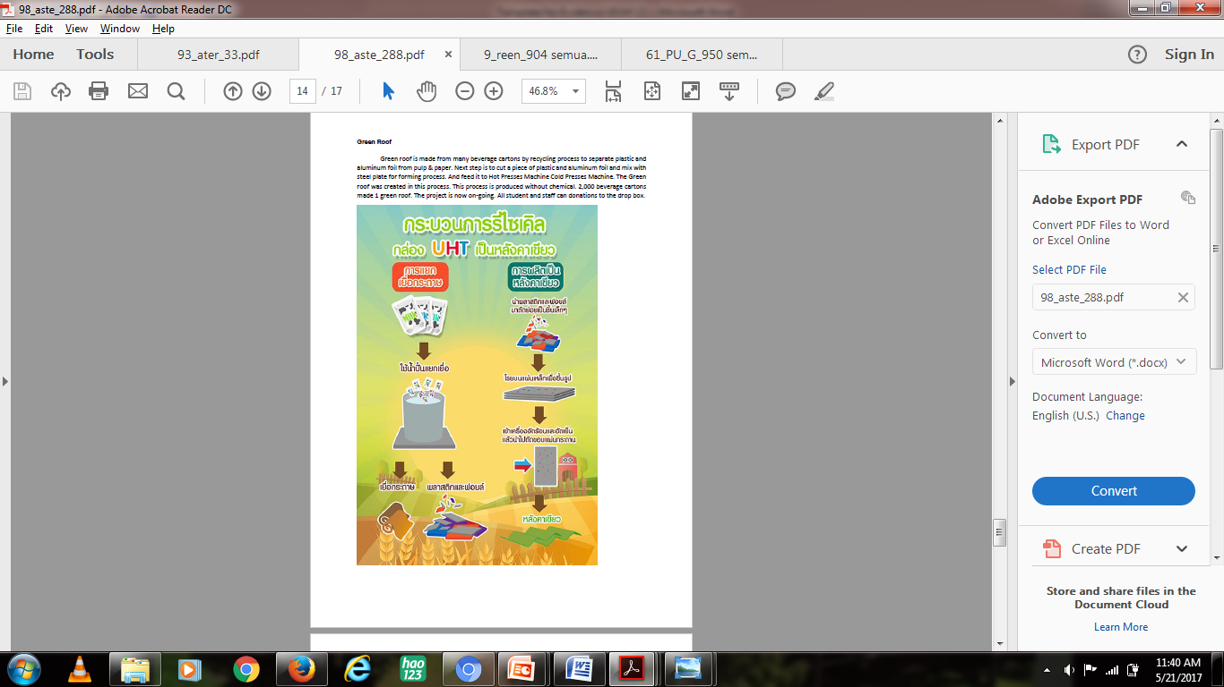
Example of 3R Program for University Waste (Mahidol University, Thailand)
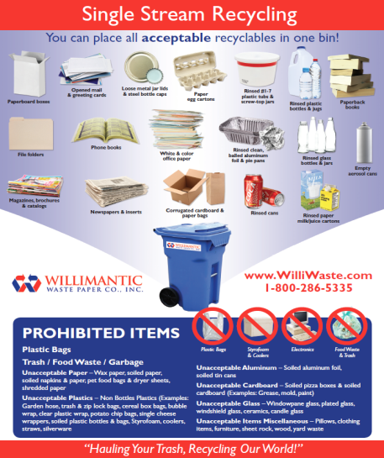
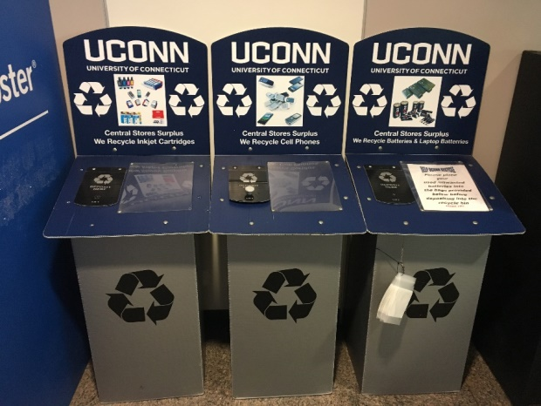
Example of 3R Program for University Waste (University of Connecticut, US)
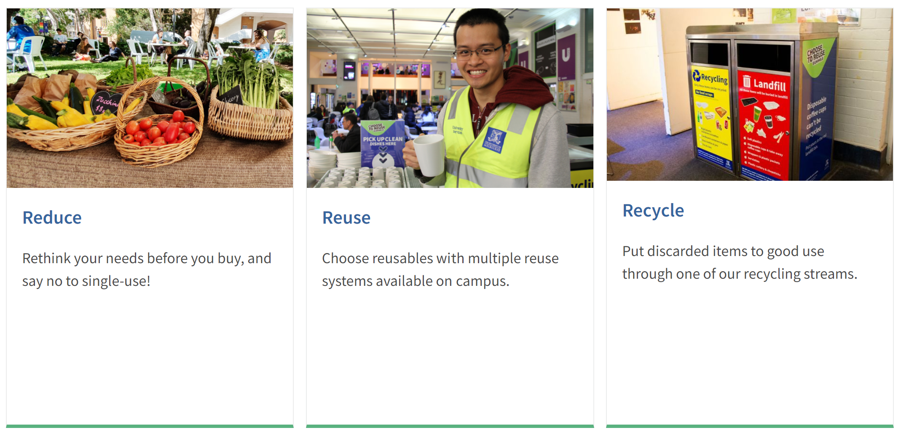
Example of 3R Program for University Waste (University of Melbourne, Australia)

Description:
(Please describe the 3R program on your campus. The following is an example of the description. You can describe more related items if needed.)

University of Connecticut uses a local recycling company, Willimantic Waste Paper Company, which has implemented Single Stream Recycling, allowing students and faculty to easily determine what they can and cannot recycle. Additionally, this program allows all types recyclables (plastic, paper, glass, aluminum) to be placed in the same container, making it easier for the user. UConn also promotes the recycling of Electronic Waste and ink-cartridges from printers. E-waste items should not be disposed of in the normal trash due to their high concentrations of toxic chemicals and heavy metals.

Additional evidence link (i.e., for videos, more images, or other files that are not included in this file):

