Template for Evidence(s)
UI GreenMetric Questionnaire

University : ...
Country : ...
Web Address : …

[4] Water (WR)
SAMPLE
[4.2] Water Recycling Program Implementation

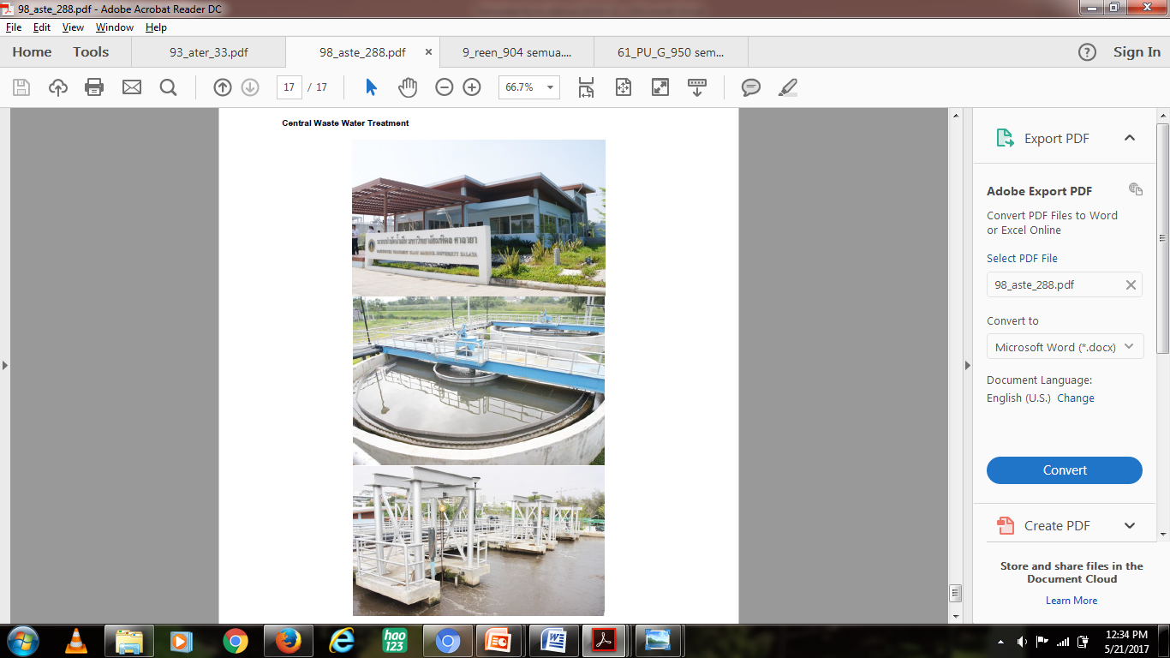 | 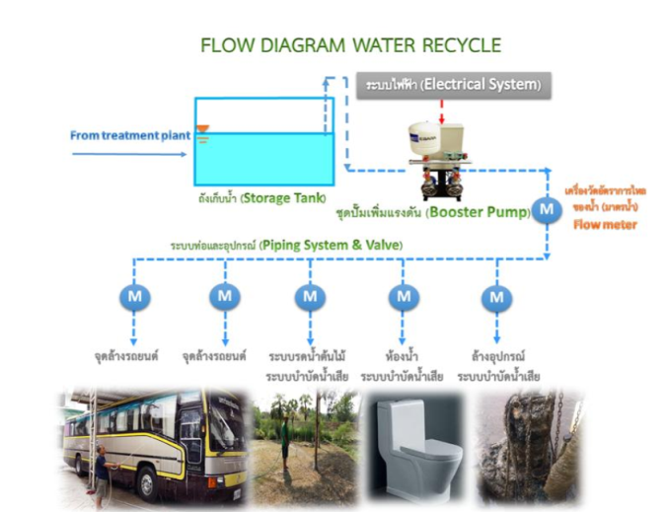
Example of Water Recycling Program (Mahidol University, Thailand)

Description:
(Please describe the water recycling program on your campus. The following is an example of the description. You can describe more related items if needed.)

A water meter is installed to measure the amount of rainwater that has been use. The recycled water also use for garden sprinkler system, toilet flush, cooling system, aquaponics and used in fish pond.

Additional evidence link (i.e., for videos, more images, or other files that are not included in this file):

