Template for Evidence(s)
UI GreenMetric Questionnaire

University : ...
Country : ...
Web Address : …

[4] Water (WR)
SAMPLE
[4.4] Consumption of treated water

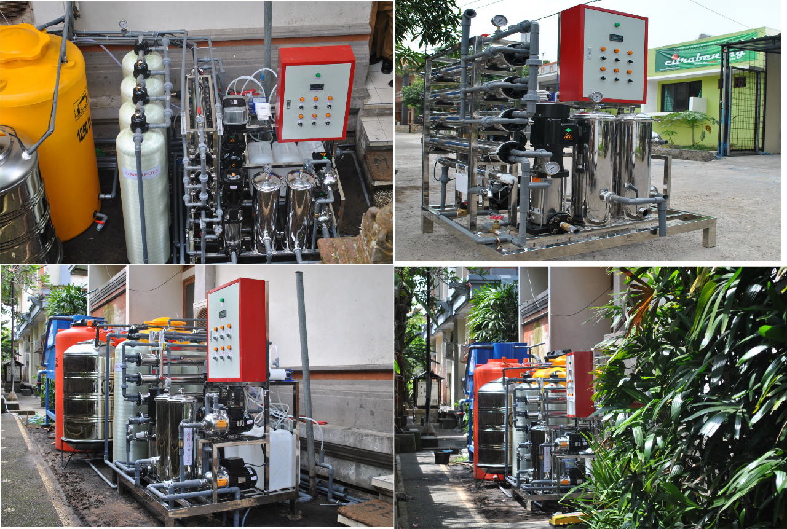
Example of Consumption of treated water (Universitas Islam Negeri Raden Intan Lampung, Indonesia)

Description:
(Please describe the water efficient appliances usage on your campus. The following is an example of the description. You can describe more related items if needed.)

- Water installation of treated-water and it is consumed by student and staff, it located at dormitory, central of Universitas Islam Negeri Raden Intan Lampung.

Additional evidence link (i.e., for videos, more images, or other files that are not included in this file):

