Template for Evidence(s)
UI GreenMetric Questionnaire

University : ...
Country : ...
Web Address : …

[6] Education and Research (ED)
SAMPLE

[6.7] Number of scholarly publications on sustainability

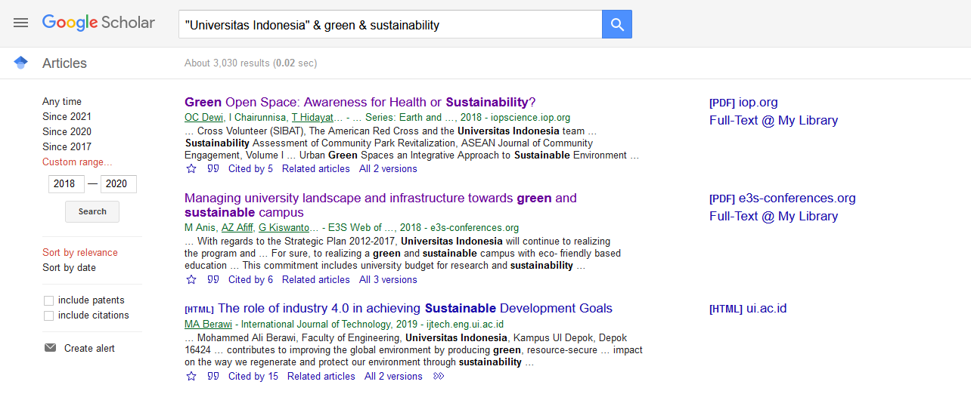
Examples of scholarly publications on sustainability (Universitas Indonesia, Indonesia)

Description:
(Please describe sustainability events on your campus. The following is an example of the description. You can describe more related items if needed.)

Example of events scholarly publications on sustainability in the academic year 2018-2020.
A total average per annum over the last 3 years of 3030 publications

Additional evidence link (i.e., for videos, more images, or other files that are not included in this file):

